

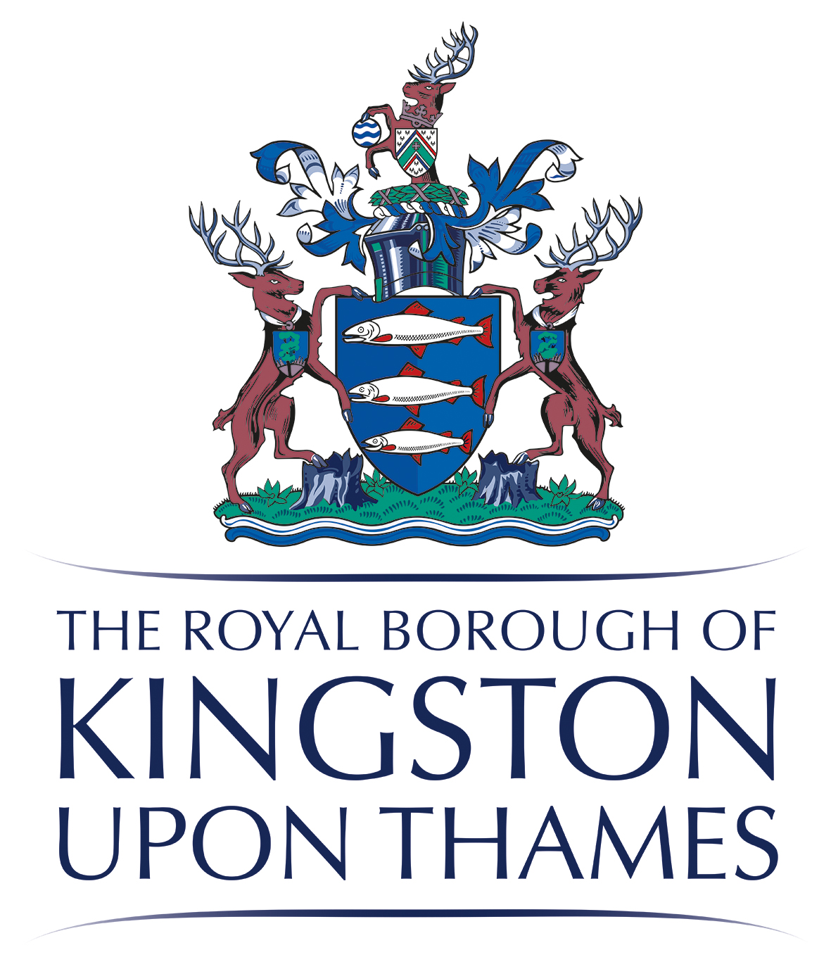

**Exercise classes –Apr 24**

(Free for people living, working or studying in Kingston or belong to Kingston GP Surgery)

**Osteoporosis Class** (Strength, Balance and bone health - 12 weeks)

St. George’s Church, Hamilton Avenue, Tolworth KT6 7PT

Starting 17th Apr, Wednesdays 13.30-14.30pm.

Balance, Bone and Muscle strength exercises for people whohave been diagnosed with osteoporosis or osteopenia or at risk of developing them. Some risk factors include - A broken bone after a minor bump or fall, family history of hip fracture or osteoporosis, early menopause (before 45), rheumatoid arthritis, Cancer, regularly taking corticosteroid tablets, smoking, or consuming more than 3 units of alcohol per day.

**Strength and Balance Class** (10 weeks)

Surbiton Hill Methodist Church, 39 Ewell Road, KT6 6AF

Starting 18th Apr Thursdays 13.15-14.15pm

Muscle strength and balance exercises for people with one or more long term health conditions.

**Strength and Balance Class** (10 weeks)

New Malden Library, 48 Kingston Road, New Malden KT3 3LY

Starting 19th April, Fridays 12.00-13.00pm

Muscle strength and balance exercises for people with one or more long term health conditions.

**Osteoarthritis Knee Class** (12 weeks)

New Malden Library, 48 Kingston Road, New Malden KT3 3LY

Starting 19th April, Fridays 10.30-11.30am.

Exercise and information sessions for people you have been diagnosed with knee osteoarthritis.

**Please let us know**:

If you are unable to attend these sessions but interested in future sessions (Online or face to face).

**Places are limited**. Please register by contacting us on

**Tel:** 0300 123 8086

**Email:** [swlicb.betterbones@nhs.net](mailto:swlicb.betterbones@nhs.net)